Fruit Pies
All our pies are made by hand using fresh ingredients. The pies arrive frozen and uncooked, ready to be baked in your oven.
*All of our pies contain wheat and dairy. Made in our kitchen, that also processes peanuts, tree nuts, eggs, soy and dairy.

Chicken Pot Pie
Also available are homemade Chicken Pot Pies. These delicious pot pies are made with all-natural Griggstown chicken, vegetables, topped with our all-butter puff pastry, and home-made gravy. They will feed a family of four, making a dinner meal, easily.

Heartworks Fundraiser for Matthew Harms
All orders must be prepaid by cash or check payable to: HEARTWORKS
Last Day to Order is Friday November 16th, 2012

Send order forms to school office
Pick up at TBS in the cafeteria
2pm – 6pm on Monday, November 19, 2012

??? Contact Laura at laurahartnett@verizon.net or (908) 766-3979

Item Price Quantity Total
Apple Pie 10” $16.00 # $___________
Apple & Blueberry Pie 10” $16.00 # $___________
Apple Crumb with Oatmeal
& Walnuts Streusel 10 “ $16.00 # $___________
Blueberry Pie 10” $16.00 # $___________
Peach Pie 10” $16.00 # $___________
Peach & Berry Pie 10” $16.00 # $___________
Cherry Pie 10” $16.00 # $___________
Pecan 10 “* $16.00 # $___________
Pumpkin 10” * $16.00 # $___________
Sweet Potato 10 “* $16.00 # $___________
Strawberry Rhubarb with Oatmeal
& Walnuts Streusel 10 “ $16.00 # $___________
Chicken Pot Pie $21.00 # $___________
TOTAL # $___________
*Fully Cooked. Just needs to be defrosted

Last Name:________________ First Name:_________
Email: ____________________ Phone:_____________
My order will be picked up by:____________________
Heartworks’Pie Fundraiser
for Matthew Harms
All proceeds to offset the expenses incurred by the family for his medical care.
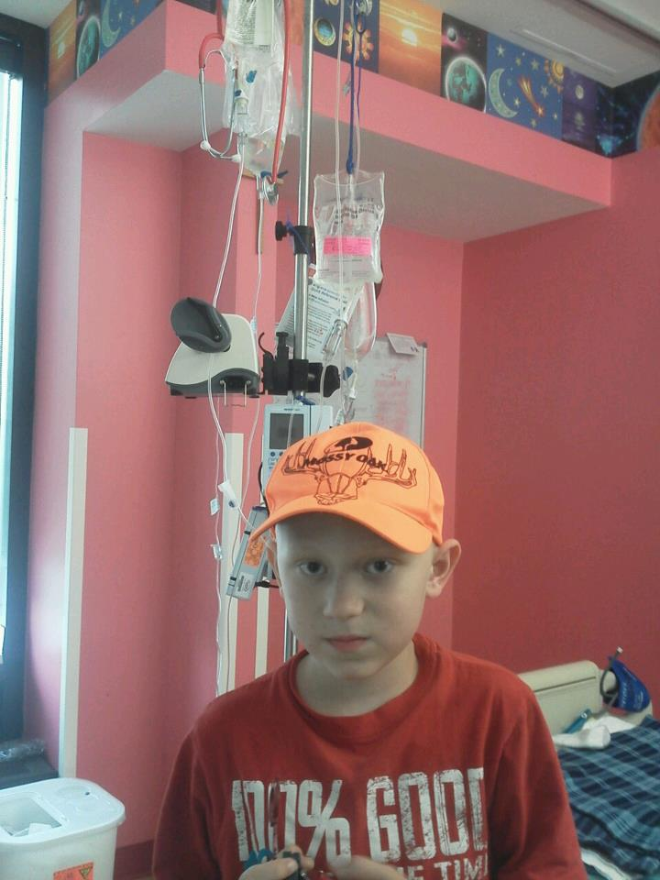
Matthew is a smart and funny 9 year old boy who loves monster trucks, hunting, fishing and coin collecting. In January 2012 he was diagnosed with T Cell Acute Lymphoblastic Leukemia, T-ALL. Over the past 9 months, he has suffered through constant meds, needles, IVS, x-rays, MRIs, pills, injections, fevers, blood transfusions, pain, doctor visits, etc. Although he is now in remission, he requires at least 3 more years of various treatments. September 24th was his first day to school in 9 months. Matthew’s parents are Rebekah and Wally; Wally is a 1989 Bernards High School graduate. Matthew has 2 sisters, Leah (11) and Karley (3), and a dog named Lilly. 100% of all monies raised from this pie sale will go directly towards his treatment costs.

Please pass along to friends and family!
Last Day to Order is Friday, November 16th!!!
Contact Laura with questions at laurahartnett@verizon.net or (908) 766-3979

Pick up pies at TBS in the cafeteria:
2-6 p.m. on Monday, November 19, 2012

Heartworks is a 501c3 created in response to the tremendous kindness that sustained so many families in the months and years following September 11, 2001.
Learn more at www.njheartworks.org

