Please do not Write on this Page.

Cell Division – Pipe Cleaner Activity

Introduction – Multicellular organisms, like you, begin as a single cell. In this activity, you explore how a cell reproduces (divides) to form two new cells. In this activity, you model each stage of the cell cycle using pipe cleaners to represent chromosomes. Your somatic cells (body cells) have 46 chromosomes. For this simulation, you will use 2 chromosomes for simplicity.

Materials:
Activity Report
Colored pencils, pens, or crayons
2 large paper plates
4 pipe cleaners (2 of color “A”, 2 of color “B”)

Procedure:
Step 1: Take two plates and stack them one on top of the other. The plates represent a cell. Place 2 pipe cleaners (1 of each color) on the top plate. This represents a cell with 2 uncopied chromosomes.
- Using colors draw a picture of this cell on your Activity Report.
- Draw a nuclear membrane around these chromosomes to show the nucleus.

Step 2: Group 2 pipe cleaners of the same color next to each other. Twist each pair together by one turn at the midpoint. Each “X” represents a duplicated chromosome. Chromosomes duplicate (are copied), through the process of DNA replication. The copying of DNA occurs before mitosis, in the S phase of Interphase.

Step 3: Put these duplicated chromosomes on the top plate. This is a cell with 4 copied chromosomes in Prophase.
- Using colors draw a picture on your Activity Report.
- Add & label centrioles, spindle fibers, & centromeres to your picture!!!

Prophase can be recognized when the chromosomes become visible with a microscope.

Step 4: Line up the chromosomes in a single line in the middle of the plate.
- Draw a picture of this cell on your Activity Report. This represents a cell in Metaphase.

Step 5: Now separate each duplicated chromosome by untwisting them. Leave them side by side on the midline that runs through the center of the plate. Next, move one single chromosome to the left side of the plate and one to the right.
- Draw a picture on your Activity Report. This represents a cell in Anaphase.
- Add spindle fibers & centrioles to this picture.

Step 6: Take the two plates and put them side by side similar to the telophase diagram in the Activity Report. Place one set of chromosomes on each plate. Each daughter cell should look identical to each other and to the original parent cell.
- Draw a picture on your Activity Report.

Step 7: Towards the end of telophase, the last phase of mitosis, cytokinesis begins. The cytoplasm is divided up & the sides of the membrane pinch in forming a cleavage furrow if it’s an animal cell.
- On your activity report, draw the chromosomes unwinding back to chromatin form & nuclear membranes reforming around the DNA.
- The spindle fibers and centrioles disappear at the end of telophase.
- Label the cleavage furrow.

Activity Report

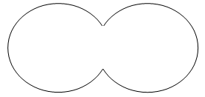
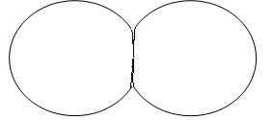
Anaphase - Drawing for Step 5.
Telophase - Drawing for Step 6.
Cytokinesis Drawing for Step 7.
Drawing for Step 1, Original Cell in Interphase
Prophase - Drawing for Step 3.
Metaphase - Drawing for Step 4.

Review Questions:
1. Compare the chromosome number of the parent cell with that of each daughter cell.

2. Compare the genetic information of the parent cell with that of each of the two daughter cells.

3. You have 46 chromosomes in each of your somatic cells. If you cut your arm, how many chromosomes would be in each newly formed skin cell?

4. Why must you do mitosis?

5. Examine the diagram below and label the phase each cell is in. Cells are either in Interphase, Prophase, Metaphase, Anaphase, Telophase/Cytokinesis.
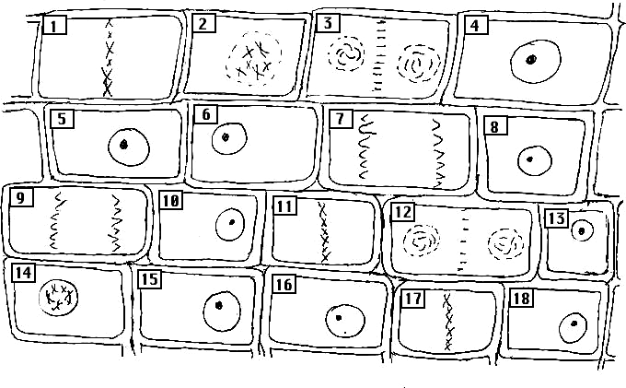
- ______________
- ______________
- ______________
- ______________
- ______________
- ______________
- ______________
- ______________
- ______________
- ______________
- ______________
- ______________
- ______________
- ______________
- ______________

6. According to the diagram, cells spend most of the time in which phase? ________________

